**What is auto bed leveling ?**

In open source delta 3D printer like Kossel,Delta.

The level of the bed is controlled by human ,which is not easy to make it horizontal.

That’s why people need to use the auto bed leveling function to adjust the level of bed before printing .

In our 3D printer ,the bed is fixed on the bottom ,we do not have this kind of problem, you can print without checking.

**How can I use auto bed leveling ?**

It’s very easy .

Follow the manual ,assemble the distance sensor.

Send command G28 first ,then send command G29 ,the printer will do a series of actions ,this is really cool ,works like a robot.

Before you use this function at first time ,you must do these things.

* You must calibration the three axises with M666
* Use M119 to check if the distance sensor can work.

Move the printer head down ,when the distance sensor is close to the bed ,the LED light on the tail of the sensor will light up ,then you send command M119 ,the status of endstop Z_min will be ‘triggered’, then you check the distance between the nozzle and the bed .

You need to modify the value of distance in Configuration.h in the firmware.

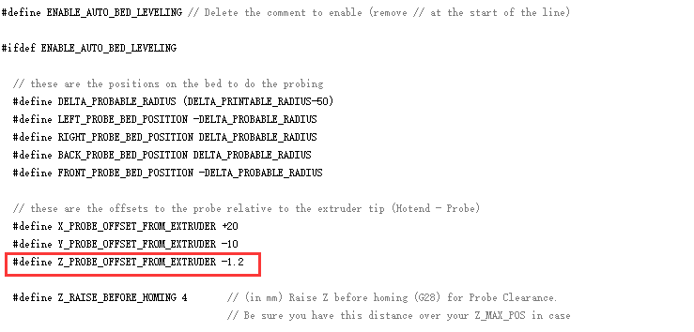

Then upload the firmware again.

The distance sensor can works in 2-3mm .

If you make the head of the sensor too high ,it will not work ,even when the nozzle crash the bed.

**How can I set G29 command in Slice engine.**

For example .

CuraEngine:

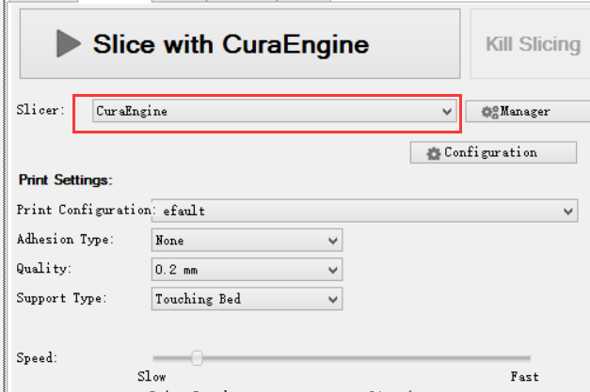

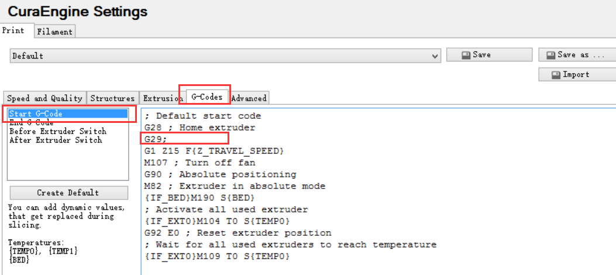

Slic3r:

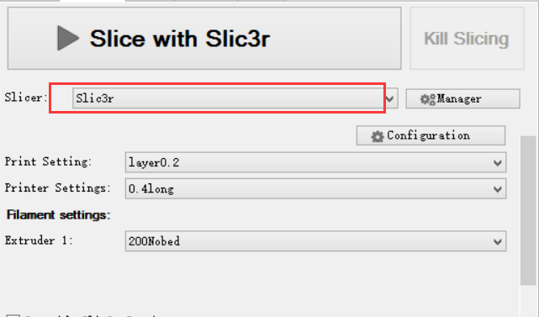

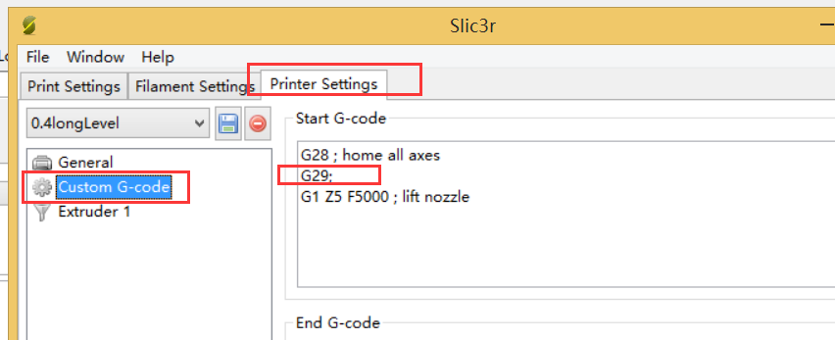

Any other questions ,pleas contact us.

Mail of our engineer : Kevin

[kaichang365@hotmail.com](mailto:kaichang365@hotmail.com)

Our online store: <http://www.aliexpress.com/store/1373025?spm=2114.10010108.0.622.XljozX>